## **Objectives**

Familiar with Git commands like git init, git status, git add, git commit, git push, and git pull.

In this hands-on lab, you will learn how to

* Setup your machine with Git Configuration
* Integrate notepad++.exe to Git and make it a default editor
* Add a file to source code repository

**Setup your machine with Git Configuration**

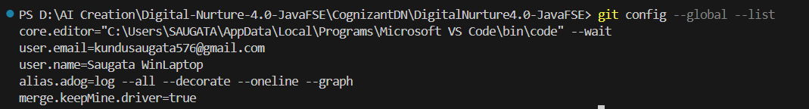

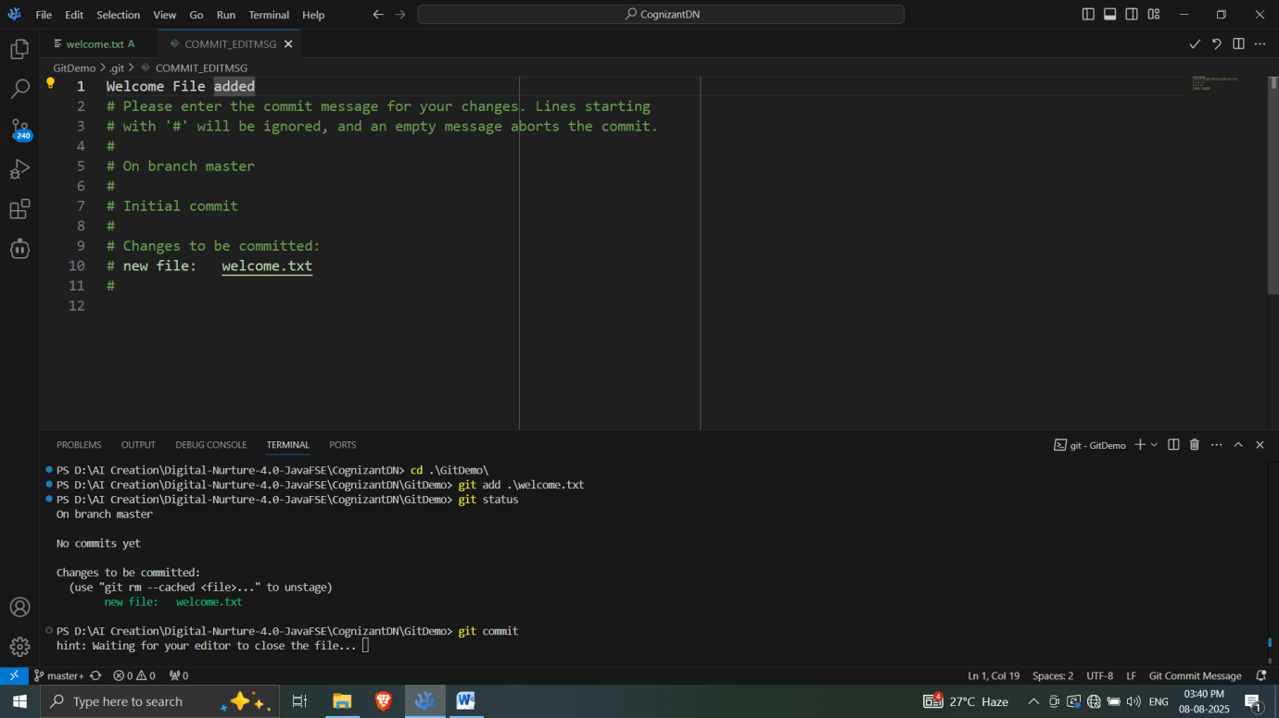

**GitLab repo -** [**Link to GitDemo**](https://gitlab.com/kundusaugata576/gitdemo)